Total Faculty Populations

**Data till May**

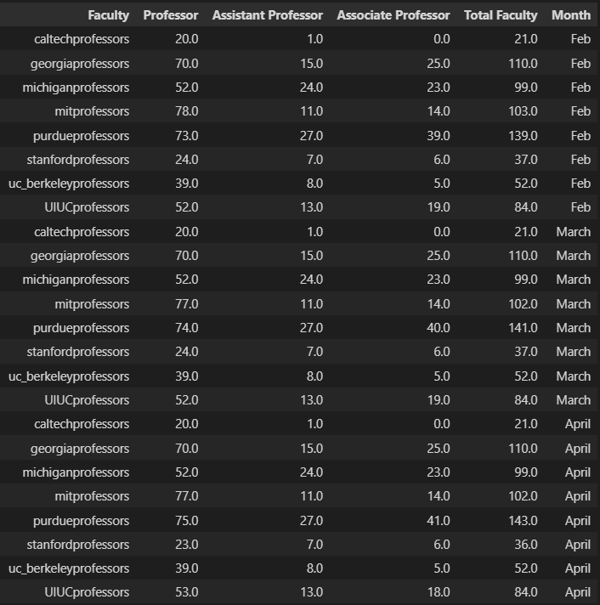

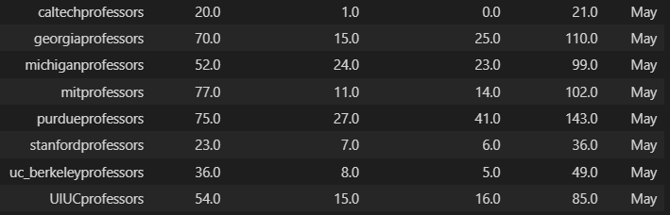

**Graphs**

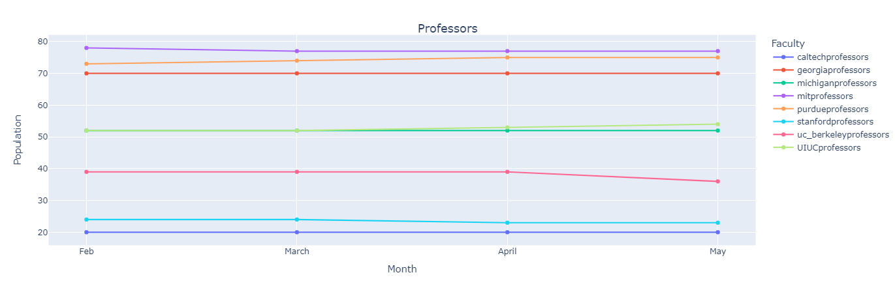

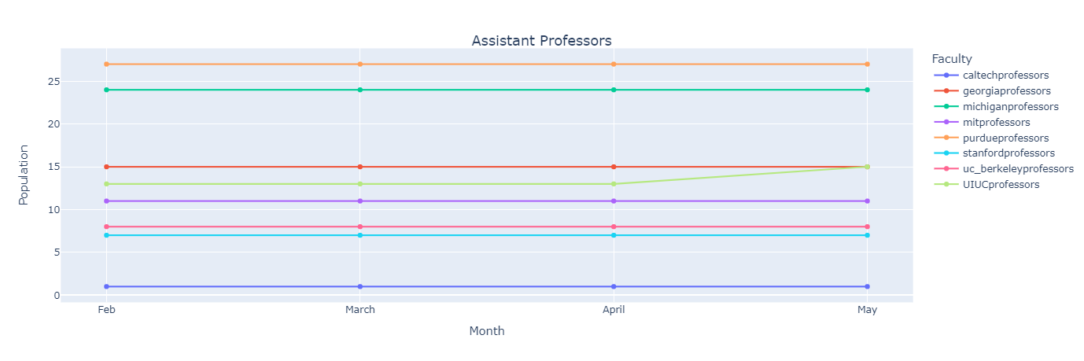

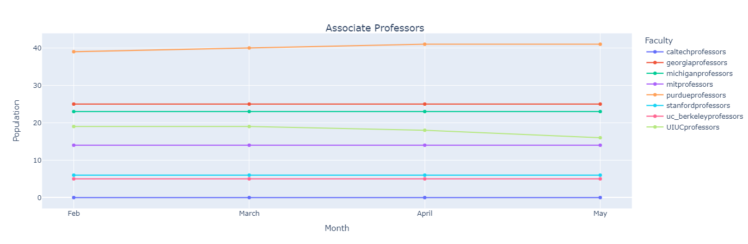

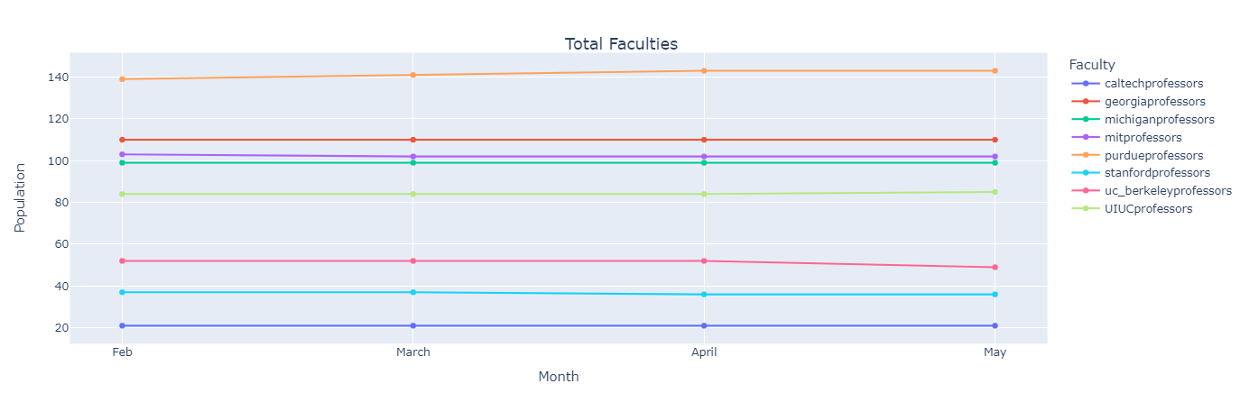

Month over Month Changes in Faculty

**Data till May**

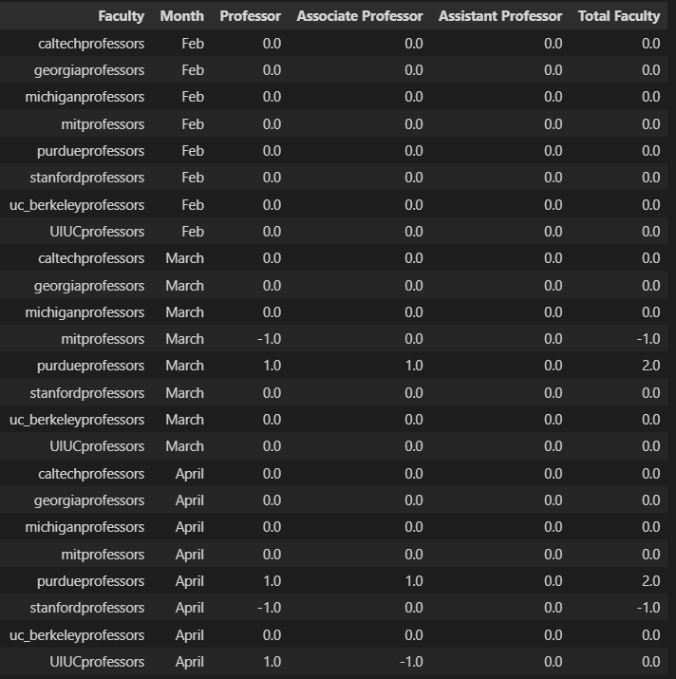

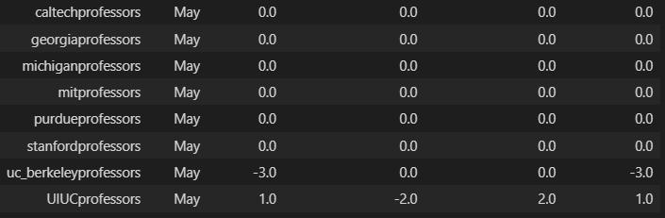

**Graphs**

